Lab3: Using Pandas for Machine Learning

Student Number: Olamilekan Elegbede
Student Name: 41273681
Using Lab3.ipynb file answer the following Questions. Submit the word document with screenshots and answer to each question

Sample Output:
Q1. Whose name is assigned to the 0th index in the dataframe (Sample Output)?
First Show your Notebook Code with your name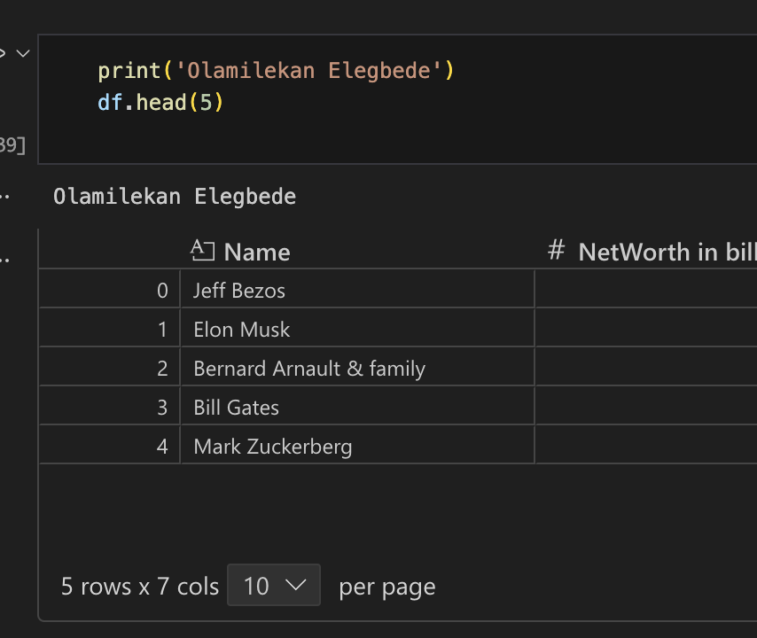

Q1. Whose name is assigned to the 0th index in the dataframe (Sample Output)?
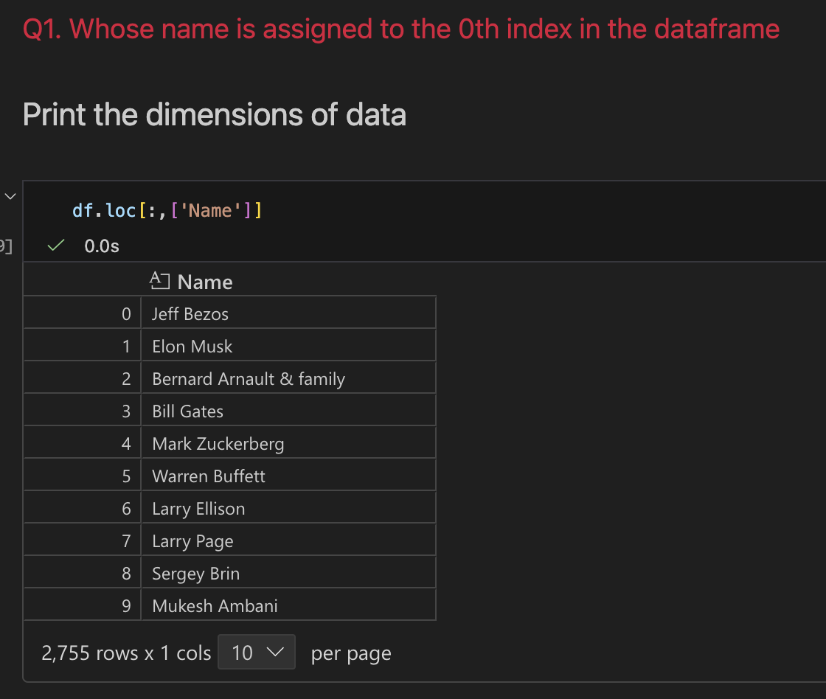
Answer to Q1: Jeff Bezos
Q2. How many records do you have in this dataset?
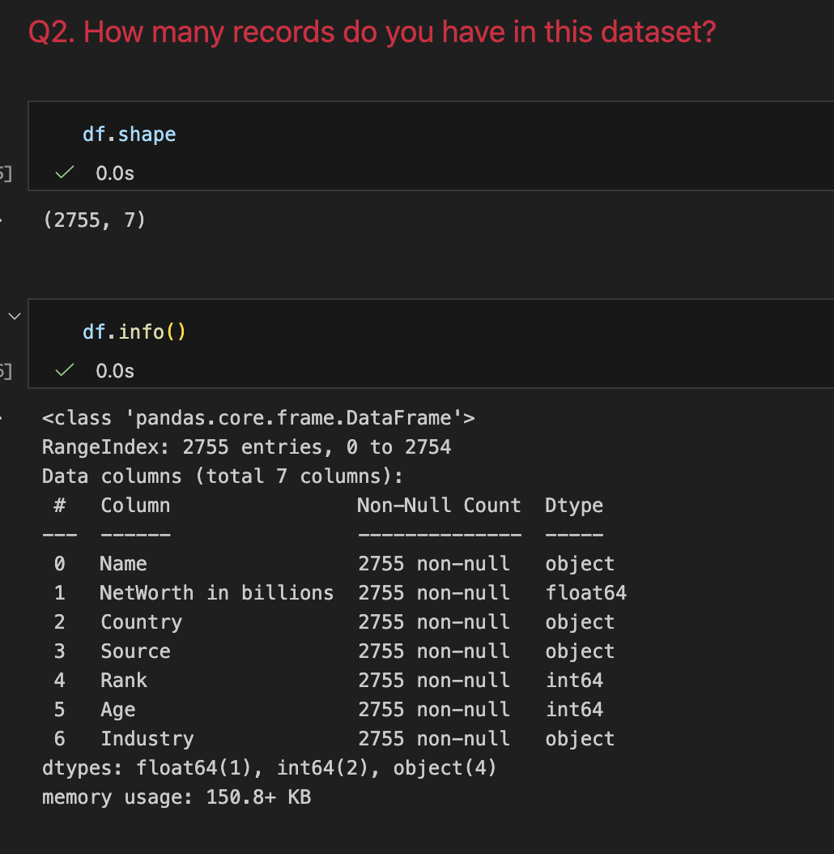
Answer to Q2: 2755 records
Q3. What is the data type of the variable Source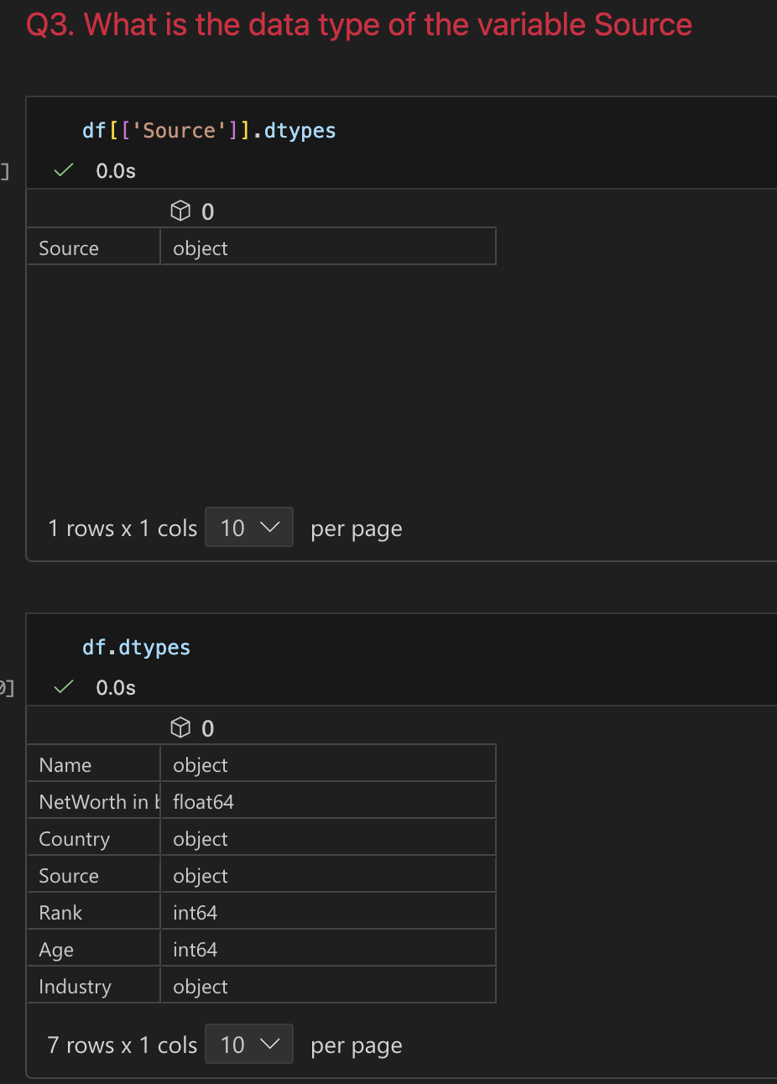
Answer to Q3: Object/String
Q4. How many missing values exists in the industry feature
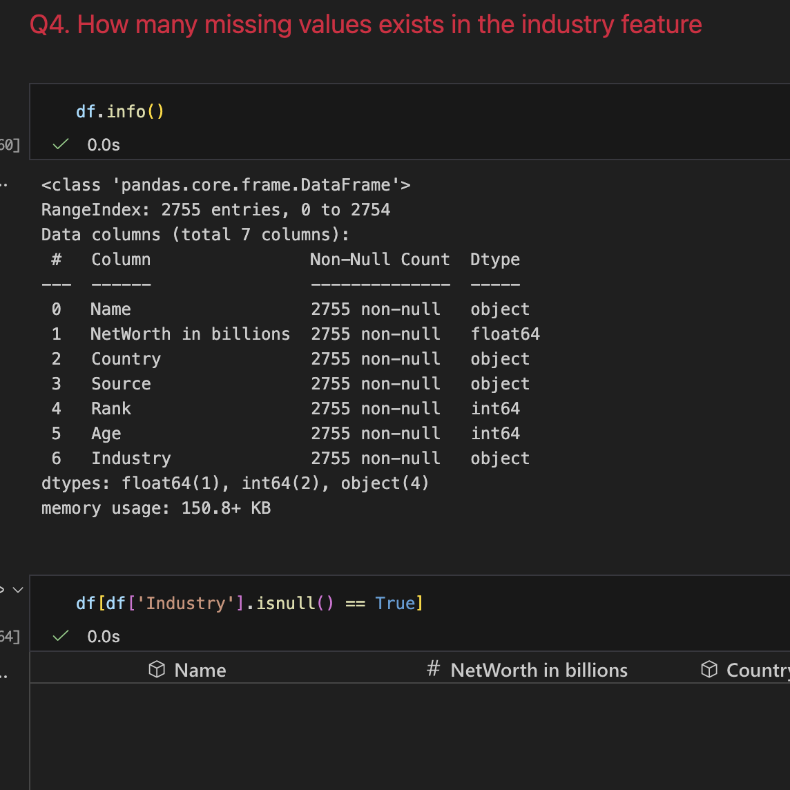
Answer to Q4: Zero
Q5. Who is the yongest billionare in this list?
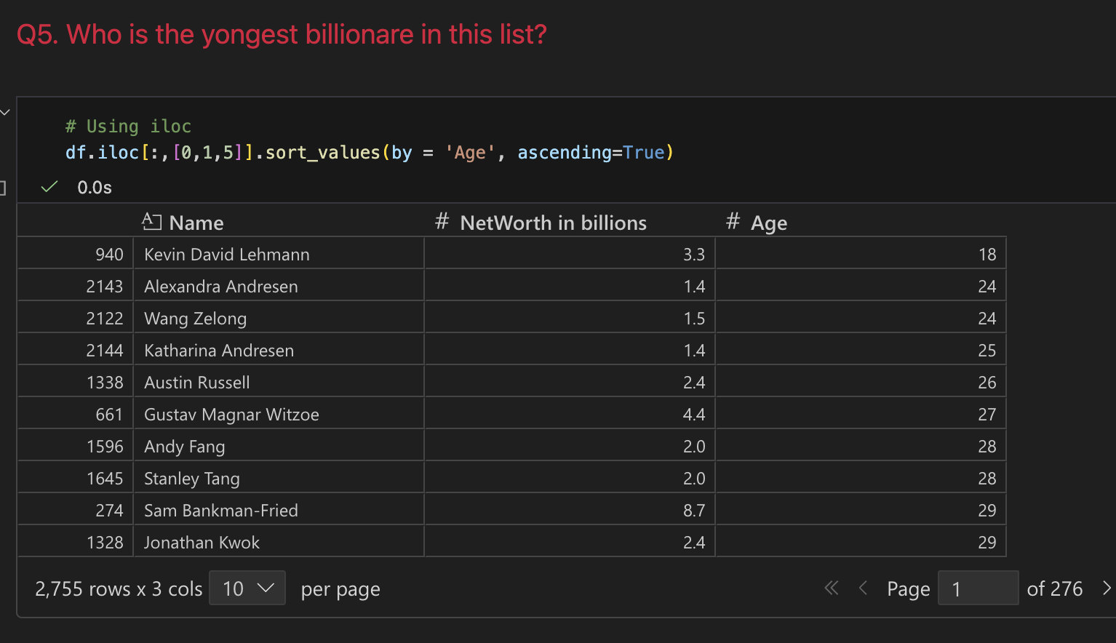Answer to Q5: Kevin David Lehmann
Q6. What is the output of `df.iloc[1200,3]?
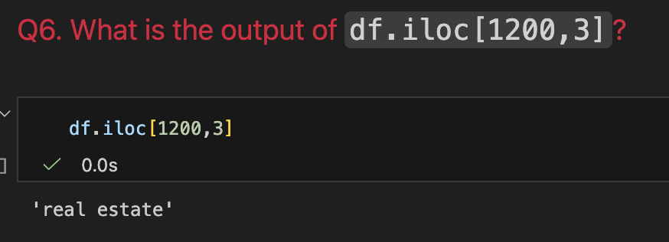
Answer to Q6: real estate
Q7. How many Billionaires were born in 1996?
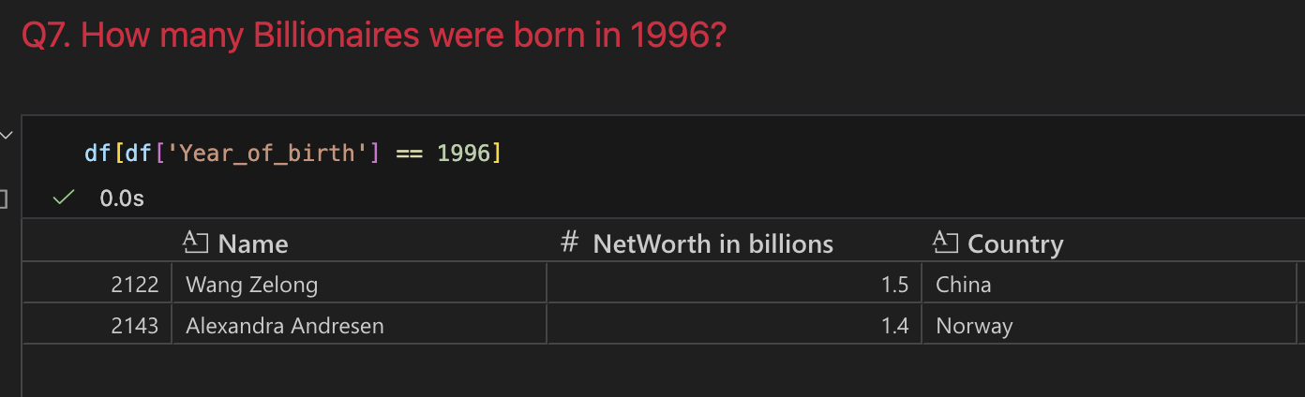Answer to Q7: Two (2)

